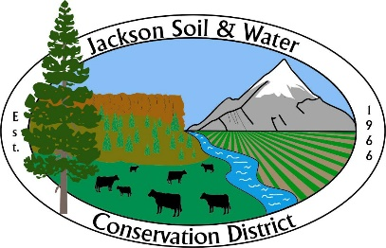

AGENDA
Jackson SWCD Board of Directors Board Meeting

Date: January 17, 2024
Time: 4:00 PM
Location: 89 Alder Street Central Point, OR 97502
Or via Zoom at: https://us02web.zoom.us/j/81833912063
____________________________________________________________________

- Call to Order, Introductions, and Pledge of Allegiance Chair

- Administration Chair
    - Preview agenda: additions, deletions, corrections
    - Approve meeting minutes from December 20, 2023*
    - Approve Treasurer’s report*

- Partner Reports Partners
    - Rogue River Watershed Council (RRWC)
    - Natural Resource Conservation Service (NRCS)
    - Colleen Roberts – Jackson County Commissioner

- Discussion Items
    - Watershed Friendly Stewardship Program Amy Wilson, guest
    - Board procedures on action items* Chair/Board
Robert’s Rules of Order and Board Room Rules handouts provided by Director Niedermeier for inclusion in board packet.

- Quarterly Staff Report* All Staff

- Action Items Executive Director/Chair
    - Delegation of authority to advocate
Recommended action: Replace Nicky Webb-Smith and approve amended resolution 20-05/97.
    - Election of officers
Recommended action: Elect Chair, Vice-Chair, and Treasurer/Secretary.

    - Appoint Associate Directors
Recommended action: Appoint Associate Director(s).

    - Annual meeting resolution
Recommended action: Approve Resolution 24-01/113.

    - Internal controls*
Recommended action: approve the updated internal financial controls.

    - Cultural Agility training contract
Recommended action: Approve one of the options for a contract with Gilda Montenegro-Fix and delegate signatory authority.

    - Executive Director performance and development plan*
Recommended action: Approve the Board Chair move forward with implementing the Executive Director Performance and Development Evaluation structure.

- Updates (as needed)
    - Legislative Chair
    - OWEB Small Grants Niedermeyer
    - OACD, SWCC Chair

- Agenda build Chair
Future board meeting topics:
    - Wildlife Habitat Conservation Management Program
    - Weed management

- Public Input Public Comment

- Adjourn Chair

Note: Executive Sessions must have a motion stating the reason (ORS number) to open the executive session and a motion to close the executive session.

