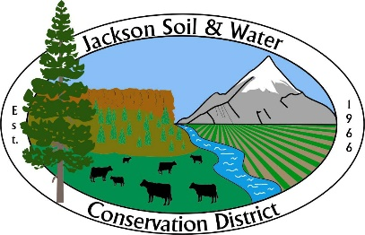

AGENDA
Jackson SWCD Board of Directors Board Meeting

Date: April 24, 2024
Time: 4:00 PM
Location: 89 Alder Street Central Point, OR 97502
Or via Zoom at: https://us02web.zoom.us/j/81833912063
____________________________________________________________________

- Call to Order, Introductions, and Pledge of Allegiance Chair

- Administration Chair
    - Preview agenda: additions, deletions, corrections
    - Approve meeting minutes from March 20, 2024*
    - Approve Treasurer’s report*

- Partner Reports Partners
    - Rogue River Watershed Council (RRWC)
    - Natural Resource Conservation Service (NRCS)
    - Colleen Roberts – Jackson County Commissioner

- Staff Reports
    - Quarterly Financial Report* Business Manager
    - Quarterly Staff Reports* All Staff

- Updates (as needed)
    - Legislative Chair
    - OWEB Small Grants Niedermeyer
    - OACD, SWCC Chair

- Discussion Items
    - Director elections* Chair

- Executive Session Chair
    - Executive Director annual performance evaluation - ORS 192.660(2)(i)

- Agenda Build Chair
Future board meeting topics:
    - Conservation Assistance Program structure update: May
    - Wildlife Habitat Conservation Management Program: TBD
Revisit after rulemaking is complete.

- Public Input Public Comment

- Adjourn Chair

Note: Executive Sessions must have a motion stating the reason (ORS number) to open the executive session and a motion to close the executive session.

List of Acronyms
CAP: | Conservation Assistance Program
CIS: | Conservation Implementation Strategy
DEQ: | Department of Environmental Quality
EPID: | Eagle Point Irrigation District
FCA: | Farmers Conservation Alliance
GHID | Gold Hill Irrigation District
GPS: | Global Positioning System
IGA: | Inter-governmental Agreement
KSON: | Klamath Siskiyou Oak Network
LAC: | Local Advisory Committee
LBC: | Little Butte Creek
LWG: | Local Work Group
MID: | Medford Irrigation District
MOU: | Memorandum of Understanding
NOWC: | Network of Watershed Councils
NRCS: | Natural Resource Conservation Service
NWQI | National Water Quality Initiative
OACD: | Oregon Association of Conservation Districts
OCA: | Oregon Cattlemen’s Association
OCEAN: | Oregon Conservation Education and Assistance Network
ODA: | Oregon Department of Agriculture
ODF: | Oregon Department of Forestry
OEM: | Office of Emergency Management
ORS: | Oregon Revised Statutes
OSU: | Oregon State University
OWEB: | Oregon Watershed Enhancement Board
OWRD: | Oregon Water Resources Department
PSP: | Pesticide Stewardship Program
RBP: | Rogue Basin Partnership
RCPP: | Regional Conservation Partnership Program
RRVID: | Rogue River Valley Irrigation District
RRWC: | Rogue River Watershed Council
RVCOG: | Rogue Valley Council of Governments
SDAO: | Special District Association of Oregon
SORE: | Southern Oregon Regional Envirothon
SOREC: | Southern Oregon Research & Extension Center
SOW: | Scope of Work
SWAT: | Student Watershed Assessment Team
SWCC: | Soil & Water Conservation Commission
TFT: | The Freshwater Trust
TID: | Talent Irrigation District
USFS: | United States Forest Service
WOCRE: | Western Oregon Cascades Recovery Effort

