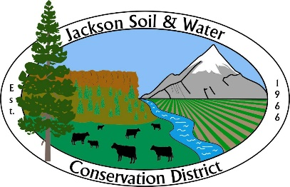

AGENDA
Jackson SWCD Board of Directors Board Meeting

Date: March 20, 2024
Time: 4:00 PM
Location: 89 Alder Street Central Point, OR 97502
Or via Zoom at: https://us02web.zoom.us/j/81833912063
____________________________________________________________________

- Call to Order, Introductions, and Pledge of Allegiance Chair

- Administration Chair
    - Preview agenda: additions, deletions, corrections
    - Approve meeting minutes from February 21, 2024*
    - Approve Treasurer’s report*

- Partner Reports Partners
    - Rogue River Watershed Council (RRWC)
    - Natural Resource Conservation Service (NRCS)
    - Colleen Roberts – Jackson County Commissioner

- Staff Presentation
    - Community Water Resource Conservation Program Update Kora Mousseaux

- Staff Reports
    - Admin Report* Executive Director

- Discussion Items
    - Annual Work Plan structure presentation Executive Director
    - Watershed Friendly Steward check-in Executive Director

- Action Items
    - Forest Conservation Technician position* Meghan Montgomery and Executive Director
Recommended action: Approve the Executive Director to move forward with hiring a 3-year term Forest Conservation Technician and approve a temporary 7% “working out of class” pay adjustment for the Forest Resource Conservationist for no more than three years.

- Updates (as needed)
    - Legislative Chair
    - OWEB Small Grants Niedermeyer
    - OACD, SWCC* Chair

- Agenda Build Chair
Future board meeting topics:
    - Executive Director annual performance review: April
Survey will be handed out to Directors at the March board meeting.
    - Conservation Assistance Program structure update: May
    - Wildlife Habitat Conservation Management Program: TBD
Revisit after rulemaking is complete.

- Public Input Public Comment

- Adjourn Chair

Note: Executive Sessions must have a motion stating the reason (ORS number) to open the executive session and a motion to close the executive session.

