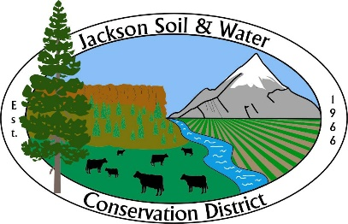

AGENDA
Jackson SWCD Board of Directors Board Meeting

Date: February 21, 2024
Time: 4:00 PM
Location: 89 Alder Street Central Point, OR 97502
Or via Zoom at: https://us02web.zoom.us/j/81833912063
____________________________________________________________________

- Call to Order, Introductions, and Pledge of Allegiance Chair

- Administration Chair
    - Preview agenda: additions, deletions, corrections
    - Approve meeting minutes from January 17, 2023*
    - Approve Treasurer’s report*

- Zone 3 Director Nominations
    - Maxine Cass* Chair
A resume and short narrative describing why Maxine Cass would like to be considered for the Zone 3 Director position is enclosed.

- Partner Reports Partners
    - Rogue River Watershed Council (RRWC)*
    - Natural Resource Conservation Service (NRCS)
    - Colleen Roberts – Jackson County Commissioner

- Guest Presentation and Discussion
    - Watershed Friendly Stewardship Program Amy Wilson, guest

- Staff Reports
    - Admin Report* Executive Director

- Action Items
    - Approval of budget calendar* Business Manager

    - ODF – Jackson SWCD Disaster Relief Agreement: approval and delegation of signatory authority * Executive Director
Recommended action: approve the ODF-Jackson SWCD Disaster Relief sub-award agreement and delegate signatory authority to the Executive Director.

- Updates (as needed)
    - Legislative Chair
    - OWEB Small Grants Niedermeyer
    - OACD, SWCC Chair

- Agenda Build Chair
Future board meeting topics:
    - Wildlife Habitat Conservation Management Program
    - Weed management

- Public Input Public Comment

- Adjourn Chair

Note: Executive Sessions must have a motion stating the reason (ORS number) to open the executive session and a motion to close the executive session.

