Board Approved
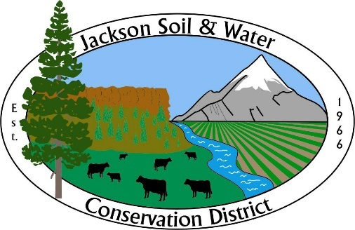
MINUTES NOT FINAL UNTIL APPROVED
Jackson Soil & Water Conservation District
89 Alder Street Central Point OR 97502
Telephone: 541-423-6159 Fax 541-727-7471
www.jswcd.org

November 20th, 2024
Jackson Soil and Water Conservation District
(JSWCD)
Board Meeting
Staff in attendance:
Jill Smedstad – Executive Director
Ellie Zignego – Outreach and Engagement Coordinator
Paul DeMaggio – Water Conservation Engineer
Kora Mousseaux – Community Water Resource Conservationist - Zoom
Michael Skandalis – Forest Conservation Technician
Meghan Montgomery – Forest Resource Conservationist
Clint Nichols – Riparian Resource Conservationist
Josh Bilbao – Agricultural Resource Conservationist - Zoom

Directors, Associates
In attendance:
Ron Hillers – Director - Zoom
Stan Dean – Director - Zoom
Pam Hillers – Associate Director – Zoom
Maxine Cass – Director
Don Hamann – Director
Frank Baratta – Director
Barbara Niedermeyer – Director
Katelyn Detweiler - Director

Guests/Partners
Eric Nusbaum – ODA
Peter Winnick – NRCS
Blake Elliot

Director Niedermeyer called the meeting to order at 4:00 pm followed by the pledge of allegiance.

October Meeting Minutes
A motion by Director Detweiler with a second by Director Baratta to approve the October Board meeting minutes passed unanimously.

Treasurers Report
A motion by Director Hillers with a second by Director Cass to approve the Treasurers Report passed unanimously.

Annual Report and Audit
A motion by Director Cass with a second by Director Hamann to approve the 2023-2024 Annual Report and Financial Audit passed unanimously.

OWEB Grant Signatory Authority
Executive Director Smedstad gave a brief overview of the OWEB grant agreement 224-2029-23717 Antelope Creek RM 4.3 Riparian Restoration and Water Quality Improvement Project. Director Dean asked Clint where the $900,000 match to the project coming from. Clint stated that is coming from a couple different places to include drinking water providers partnership, CAP funds, staff time, and NRCS EQIP program through NWQI or IRA. A motion by Director Baratta with a second by Director Cass to delegate signatory authority to the Executive Director for the OWEB 23717 Antelope Creek RM 4.3 grant passed unanimously.

Policy Review and Recommendations
Executive Director Smedstad briefly reminded the Board that the policy review and recommendations were brought to the Board at the previous meeting for review.
A motion by Director Detweiler with a second by Director Hamann to repeal the enclosed policies from 2001-2005 that are no longer applicable, as listed in the enclosed policy list, passed unanimously.

Director Compensation Resolution
Following the discussion in the previous meeting, Director Dean and Executive Director Smedstad implemented the recommended revisions to the Director Compensation Resolution. These changes include clarifying the compensation structure for meetings and defining the criteria for what qualifies as a meeting eligible for compensation. A motion by Director Baratta with a second by Director Cass to amend Resolution 07-04/05 as presented, to include Associate Directors and Director Emeritus for compensation while representing the District, passed unanimously.

Staff Quarterly Reports

Jill: Jill, Jenna, and Paul will present the Pilot Metrics and Monitoring Program Water Quality Plan at the January or February board meeting. Nature’s Landscape LLC installed a retaining wall and updated the front landscaping, along with the two planter boxes on the north side of the building, using native and drought-tolerant plants. Jill is working with Sue Parrish from OWRD to bring together partners for a working group to launch a collaborative water planning and action process in the 'Inland Rogue' region. The goals of this group are to address long-term water resource challenges in the Inland Rogue watershed, build local capacity, and collaborate on shared actions to respond to changing water availability and growing demands. Executive Director Smedstad

NRCS Update
Peter Winnick with NRCS gave the Board an update on current projects. They are about a week and a half away from their application deadline for most of their programs through this year. They are going to be doing a big forestry project in the Applegate area as well as the RCPP with the West Bear project.

ODA Update
Eric Nusbaum with ODA congratulated new and existing Board members on their elections. He stated there would be a Director training this winter. He is working on getting certified to do the new public meeting law training and will hopefully offer that training soon. Deschutes SWCD is the newest District with a tax base. Eric is updated the SWCD guidebook as well, he has updated the first four chapters and is continuing to work through it.

Agenda Build
Public Meeting Policy and Training
Dispute Resolution Policy Update
Wildlife Habitat Conservation Management Program
JSWCD Equity and Environmental Justice Statement

Public Input
None

The meeting was adjourned at 4:45pm.

Respectfully submitted by: ____Trevor Morris_____________
Business Manager
Minutes approved as printed:

___________________________________________________________________ Date __________________

Approved as amended:

_____________________________________________________________________ Date___________________

